UNITED STATES

SECURITIES AND EXCHANGE COMMISSION
Washington, D.C. 20549

FORM 8-K

CURRENT REPORT

Pursuant to Section 13 or 15(d)

of the Securities Exchange Act of 1934

Date of Report (Date of earliest event reported): January 14, 2019

MICROBOT MEDICAL INC.

(Exact name of registrant as specified in its charter)

Delaware | 000-19871 | 94-3078125
(State or other jurisdiction | (Commission | (IRS Employer
of incorporation) | File Number) | Identification No.)
 | 25 Recreation Park Drive, Unit 108
 | Hingham, Massachusetts 02043
 | (Address of Principal Executive Offices) (Zip Code)
 | Registrant’s telephone number, including area code: (781) 875-3605

(Former Name or Former Address, if Changed Since Last Report)

Check the appropriate box below if the Form 8-K filing is intended to simultaneously satisfy the filing obligation of the registrant under any of the following provisions:

- ] Written communications pursuant to Rule 425 under the Securities Act (17 CFR 230.425)

- ] Soliciting material pursuant to Rule 14a-12 under the Exchange Act (17 CFR 240.14a-12)

- ] Pre-commencement communications pursuant to Rule 14d-2(b) under the Exchange Act (17 CFR 240.14d-2(b))

- ] Pre-commencement communications pursuant to Rule 13e-4(c) under the Exchange Act (17 CFR 240.13e-4(c))

Indicate by check mark whether the registrant is an emerging growth company as defined in Rule 405 of the Securities Act of 1933 (17 CFR §230.405) or Rule 12b-2 of the Securities Exchange Act of 1934 (17 CFR §240.12b-2).

Emerging Growth Company [ ]

If an emerging growth company, indicate by check mark if the registrant has elected not to use the extended transition period for complying with any new or revised financial accounting standards provided pursuant to Section 13(a) of the Exchange Act. [ ]

Item 7.01 Regulation FD Disclosure.

On January 14, 2019, Microbot Medical Inc. (the “Company”) issued a press release announcing that it has validated the operational effectiveness of the Company’s Self-Cleaning Shunt (SCS™) in a recent independent in-vitro laboratory study. The Company also shared images of its SCS™ from the laboratory study that clearly demonstrate the device prevented shunt occlusion. A copy of the press release is furnished as Exhibit 99.1 to this Current Report on Form 8-K and is incorporated herein by reference.

On January 14, 2019, the Company issued a press release announcing that it received a notification from the European Patent Office that it will grant a patent for Application No. 08738207, which covers the Company’s ViRob™ technology platform. Including this latest notification, the Company has 30 issued/allowed patents and 18 patent applications pending worldwide. A copy of the press release is furnished as Exhibit 99.2 to this Current Report on Form 8-K and is incorporated herein by reference.

The information in this Item 7.01 and in Exhibits 99.1 and 99.2 of Item 9.01 is being furnished pursuant to Item 7.01 and shall not be deemed to be “filed” for the purposes of Section 18 of the Securities Exchange Act of 1934, as amended, or otherwise subject to the liabilities of that section. This report will not be deemed an admission as to the materiality of any information in this Item 7.01 or Exhibits 99.1 or 99.2 of Item 9.01.

Item 9.01 Financial Statements and Exhibits.

Exhibit |  | Description
99.1 |  | Press Release dated January 14, 2019 regarding in-vitro laboratory study
99.2 |  | Press Release dated January 14, 2019 regarding ViRob™ patent

SIGNATURES

Pursuant to the requirements of the Securities Exchange Act of 1934, the Company has duly caused this report to be signed on its behalf by the undersigned thereunto duly authorized.

MICROBOT MEDICAL INC.

By: /s/ HAREL GADOT

Name: Harel Gadot

Title: President, Chief Executive Officer and Chairman

Date: January 14, 2019

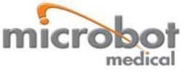

Recent Study Validates the Operational Effectiveness of Microbot Medical’s Self-Cleaning Shunt (SCSTM)

HINGHAM, Mass., January 14, 2019 –Microbot Medical Inc. (NASDAQ: MBOT) announced today that it has validated the operational effectiveness of the Company’s Self-Cleaning Shunt (SCSTM) in a recent independent in-vitro laboratory study. The Company also shared images of its SCSTM from the laboratory study that clearly demonstrate the device prevented shunt occlusion.
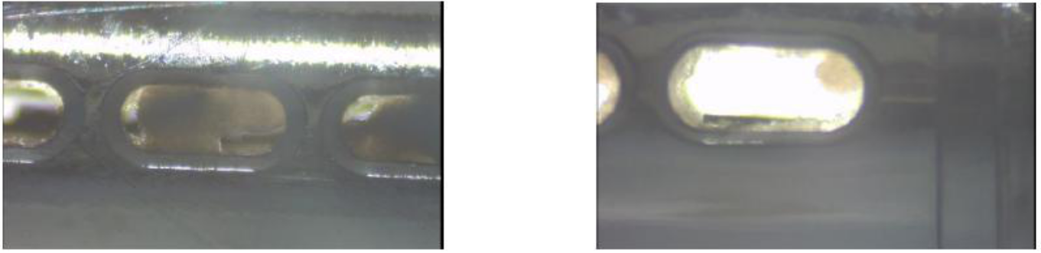

Non Activated shunt Activated Shunt
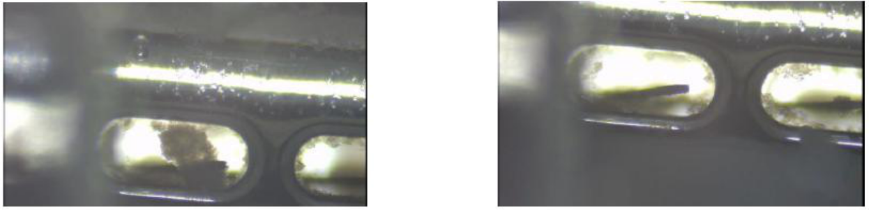

4 weeks cell growth 10 minutes post shunt activation

“We believe the highly encouraging results from this latest study, which complements our previous pre-clinical studies, demonstrates the potential of our SCSTM product to revolutionize how Hydrocephalus and Normal Pressure Hydrocephalus (NPH) can be treated in the future,” commented Harel Gadot,

CEO, President and Chairman. “We believe the performance of the SCSTM during this and previous studies gives us greater confidence to explore additional medical applications for the device in conditions where occlusion occurs, such as in the Traumatic Brain Injury (TBI) space.”

The study was conducted at Envigo CRS Israel, a leading provider of non-clinical contract research services and research models. Human brain glioblastoma cells were used in order to assess performance of the SCSTM in a test system with accelerated cell growth rate, accumulation and obstruction rates. The study commenced in October 2018 and after 30 days it demonstrated:

- Significant cell growth and accumulation in a non-operating SCSTM; and

- A significant inhibition in cell growth in the constantly operating SCSTM with very little to no cell attachment on the robotic brush (ViRobTM) and on the opening where the robotic brush (ViRobTM) operates.

The study also demonstrated that the Company’s SCSTM has the ability to operate after cells had accumulated on the catheter holes and the robotic brush (ViRobTM). Moreover, SCSTM activation demonstrated the potential to disintegrate existing occlusions formed on the robotic brush (ViRobTM) and on the opening where the robotic brush (ViRobTM) operates.

In addition to this study, the Company previously announced data from two pre-clinical studies that were performed at leading U.S. academic institutions. Data from those studies were also presented by Professor Pat McAllister, Department of Neurosurgery, Washington University School of Medicine, St. Louis, at the International Hydrocephalus Conference, held in Bologna, Italy in October 2018.

- In-vitro study, which was performed at Wayne State University, supports the SCSTM’s potential as a viable technology for preventing occlusion in shunts used to treat hydrocephalus.

- In-vivo animal study, which was performed at Washington University School of Medicine in St. Louis, supports the safety profile of the Company’s SCSTM as a CSF catheter.

The follow up study, which is being conducted by the same academic institutions, commenced in October 2018 and includes a larger sample size compared to the initial studies. The primary and secondary endpoints will seek to validate the safety and efficacy of the SCSTM that will be activated in both in-vitro (lab) and in-vivo (animal) models. The Company’s objective is to conclude the follow up study and announce the data in the second half of 2019. The Company plans to use the findings either for its regulatory submissions in the US, Europe and other jurisdictions, or as part of a pre-submission meeting request, depending on the final results of the ongoing follow-up study.

About Envigo

With over 3,300+ employees serving over 65 countries with a network of more than 25 operating facilities worldwide, Envigo provides comprehensive scientific expertise and a full service offering in non-clinical research and development, research models and services, regulatory consulting, and analytical support to our customers. Envigo is a privately held global company with corporate headquarters in New Jersey

About Microbot Medical, Inc.

Microbot™, which was founded in 2010 and commenced operations in 2011, became a NASDAQ listed company on November 28, 2016. The Company specializes in transformational micro-robotic medical technologies leveraging the natural and artificial lumens within the human body. Microbot’s current technological platforms, ViRobTM, TipCATTM and CardioSertTM, are comprised of three highly advanced technologies, from which the Company is

currently developing its first product candidate: The Self-Cleaning Shunt, or SCSTM, for the treatment of hydrocephalus and Normal Pressure Hydrocephalus, or NPH. The Company also is focused on the development of a Multi Generation Pipeline Portfolio (MGPP) utilizing all technologies. Further information about Microbot Medical is available at http://www.microbotmedical.com.

The ViRobTM technology is a revolutionary autonomous crawling micro-robot which can be controlled remotely or within the body. Its miniature dimensions allow it to navigate and crawl in different spaces within the human body, including blood vessels, the digestive tract and the respiratory system. Its unique structure gives it the ability to move in tight spaces and curved passages as well as the ability to remain within the human body for prolonged time. To learn more about ViRobTM please visit http://www.microbotmedical.com/technology/virob/.

TipCATTM is a transformational self-propelled, flexible, and semi-disposable locomotive device providing see & treat capabilities within tubular lumens in the human body such as the colon, blood vessels, and the urinary tract. Its locomotion mechanism is perfectly suitable to navigate and crawl through natural
- artificial tubular lumens, applying the minimal necessary pressure to achieve the adequate friction required for gentle, fast, and safe advancement within the human body. To learn more about TipCATTM, visit http://www.microbotmedical.com/technology/tipcat/.

CardioSertTM technology contemplates a unique combination of a guidewire and microcatheter, technologies that are broadly used for endoluminal surgery. The CardioSertTM technology features unique steering and stiffness control capabilities, and it was originally developed to support interventional cardiologists in crossing the most complex lesions called chronic total occlusion (CTO) during percutaneous coronary intervention (PCI) procedures and has
the potential to be used in other spaces and applications, such as peripheral intervention, neurosurgery and urology. CardioSertTM was part of a technological incubator supported by the Israel Innovation Authorities (formerly known as the Office of the Chief Scientist, or OCS), and its device has successfully completed pre-clinical testing.

Safe Harbor

Statements pertaining to future financial and/or operating results, future growth in research, technology, clinical development, and potential opportunities for Microbot Medical Inc. and its subsidiaries, along with other statements about the future expectations, beliefs, goals, plans, or prospects expressed by management constitute forward-looking statements. Any statements that are not historical fact (including, but not limited to statements that contain words such as “will,” “believes,” “plans,” “anticipates,” “expects” and “estimates”) should also be considered to be forward-looking statements. Forward-looking statements involve risks and uncertainties, including, without limitation, risks inherent in the development and/or commercialization of potential products, the outcome of its studies to evaluate the SCS and other existing and future technologies, uncertainty in the results of pre-clinical and clinical trials or regulatory pathways and regulatory approvals, need and ability to obtain future capital, and maintenance of intellectual property rights. Actual results may differ materially from the results anticipated in these forward-looking statements and as such should be evaluated together with the many uncertainties that affect the businesses of Microbot Medical Inc. particularly those mentioned in the cautionary statements found in Microbot Medical Inc.’s filings with the Securities and Exchange Commission. Microbot Medical disclaims any intent or obligation to update these forward-looking statements.

Investor Contact:

Michael Polyviou

EVC Group

mpolyviou@evcgroup.com

732-933-2754

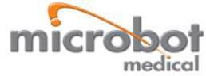

Microbot Medical Increases its Global IP Portfolio with Notice of Allowance from the European Patent Office

HINGHAM, Mass., January 14, 2019 – Microbot Medical Inc. (NASDAQ: MBOT), received a notification from the European Patent Office that it will grant a patent for Application No. 08738207, which covers the Company’s ViRob™ technology platform. Including this latest notification, the Company has 30 issued/allowed patents and 18 patent applications pending worldwide.

“The allowance of this European patent application further strengthens our global intellectual property estate covering micro-robotic technology platform,” commented Harel Gadot, CEO, President and Chairman. “As we have demonstrated since becoming a publicly traded company, we are creating significant barriers to entry and this combined with the positive safety data we continue to achieve with our Self-Cleaning Shunt (SCS™), are reinforcing our pillars for success.”

The allowed application covers an autonomous vibration-driven device for motion relative to a juxtaposed surface, such as an inner wall of a lumen. The device includes a body and an array of fibers attached thereto, with at least some of the fibers maintaining contact with the juxtaposed surface and having anisotropic surface friction therewith, such that mutual vibratory motion between the device and the juxtaposed surface causes the device to move along the surface.

About Microbot Medical, Inc.

Microbot™, which was founded in 2010 and commenced operations in 2011, became a NASDAQ listed company on November 28, 2016. The Company specializes in transformational micro-robotic medical technologies leveraging the natural and artificial lumens within the human body. Microbot’s current technological platforms, ViRobTM, TipCATTM and CardioSertTM, are comprised of three highly advanced technologies, from which the Company is

currently developing its first product candidate: the Self Cleaning Shunt, or SCSTM, for the treatment of hydrocephalus and Normal Pressure Hydrocephalus, or NPH; and focusing on the development of a Multi Generation Pipeline Portfolio (MGPP) utilizing all technologies. Further information about Microbot Medical is available at http://www.microbotmedical.com.

The ViRobTM technology is a revolutionary autonomous crawling micro-robot which can be controlled remotely or within the body. Its miniature dimensions allow it to navigate and crawl in different spaces within the human body, including blood vessels, the digestive tract and the respiratory system. Its unique structure gives it the ability to move in tight spaces and curved passages as well as the ability to remain within the human body for prolonged time. To learn more about ViRobTM please visit http://www.microbotmedical.com/technology/virob/.

TipCATTM is a transformational self-propelled, flexible, and semi-disposable endoscope providing see & treat capabilities within tubular lumens in the human body such as the colon, blood vessels, and the urinary tract. Its locomotion mechanism is perfectly suitable to navigate and crawl through natural & artificial tubular lumens, applying the minimal necessary pressure to achieve the adequate friction required for gentle, fast, and safe advancement within the human body. To learn more about TipCATTM, visit http://www.microbotmedical.com/technology/tipcat/.

CardioSertTM technology is a unique combination of a guidewire and microcatheter, technologies that are broadly used for endoluminal surgery. The CardioSertTM technology features unique steering and stiffness control capabilities, and it was originally developed to support interventional cardiologists in crossing the most complex lesions called chronic total occlusion (CTO) during percutaneous coronary intervention (PCI) procedures and has the potential to
be used in other spaces and applications, such as peripheral intervention, neurosurgery and urology. CardioSertTM was part of a technological incubator supported by the Israel Innovation Authorities (formerly known as the Office of the Chief Scientist, or OCS), and its device has successfully completed pre-clinical testing.

Safe Harbor

Statements pertaining to future financial and/or operating results, future growth in research, technology, clinical development, and potential opportunities for Microbot Medical Inc. and its subsidiaries, along with other statements about the future expectations, beliefs, goals, plans, or prospects expressed by management constitute forward-looking statements. Any statements that are not historical fact (including, but not limited to statements that contain words such as “will,” “believes,” “plans,” “anticipates,” “expects” and “estimates”) should also be considered to be forward-looking statements. Forward-looking statements involve risks and uncertainties, including, without limitation, risks inherent in the development and/or commercialization of potential products, the outcome of its studies to evaluate the SCS and other existing and future technologies, uncertainty in the results of pre-clinical and clinical trials or regulatory approvals, need and ability to obtain future capital, and maintenance of intellectual property rights. Actual results may differ materially from the results anticipated in these forward-looking statements and as such should be evaluated together with the many uncertainties that affect the businesses of Microbot Medical Inc. particularly those mentioned in the cautionary statements found in Microbot Medical Inc.’s filings with the Securities and Exchange Commission. Microbot Medical disclaims any intent or obligation to update these forward-looking statements.

Investor Contacts:

Michael Polyviou

EVC Group

mpolyviou@evcgroup.com

732-933-2754

