UNITED STATES

SECURITIES AND EXCHANGE COMMISSION
Washington, D.C. 20549
SCHEDULE 14A

(RULE 14a-101)
INFORMATION REQUIRED IN PROXY STATEMENT
SCHEDULE 14A INFORMATION
Proxy Statement Pursuant to Section 14(a) of the Securities

Exchange Act of 1934 (Amendment No. )

Filed by the Registrant ☑

Filed by a Party other than the Registrant ☐

Check the appropriate box:

- Preliminary Proxy Statement

- Confidential, for Use of the Commission Only (as permitted by Rule 14a-6(e)(2))

- Definitive Proxy Statement

- Definitive Additional Materials

- Soliciting Material Pursuant to §240.14a-12

STEMCELLS, INC.

(Name of Registrant as Specified In Its Charter)

(Name of Person(s) Filing Proxy Statement, if other than the Registrant)

Payment of Filing Fee (Check the appropriate box):

- No fee required.

- Fee computed on table below per Exchange Act Rules 14a-6(i)(4) and 0-11.

  - Title of each class of securities to which transaction applies:

  - Aggregate number of securities to which transaction applies:

  - Per unit price or other underlying value of transaction computed pursuant to Exchange Act Rule 0-11 (set forth the amount on which the filing fee is calculated and state how it was determined):
  - Proposed maximum aggregate value of transaction:

  - Total fee paid:

- Fee paid previously with preliminary materials.

- Check box if any part of the fee is offset as provided by Exchange Act Rule 0-11(a)(2) and identify the filing for which the offsetting fee was paid previously. Identify the previous filing by registration statement number, or the Form or Schedule and the date of its filing.
(1) Amount Previously Paid:

(2) Form, Schedule or Registration Statement No.:

(3) Filing Party:

(4) Date Filed:

SEC 1913 (02-02) Persons who are to respond to the collection of information contained in this form are not required to respond unless the form displays a currently valid OMB control number.

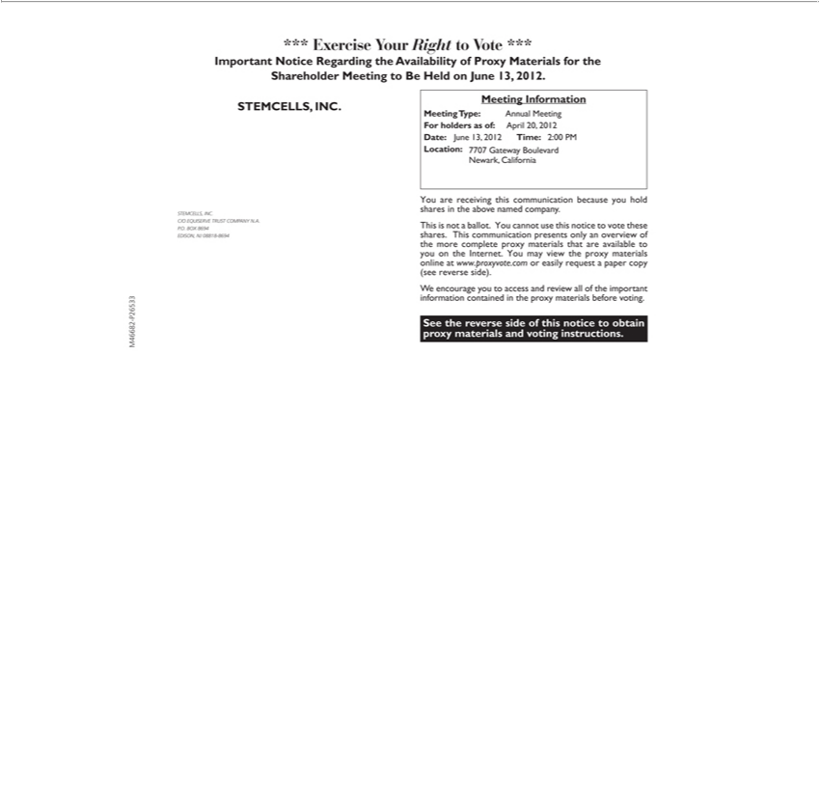

*** Exercise Your Right to Vote ***
Important Notice Regarding the Availability of Proxy Materials for the Shareholder Meeting to Be Held on June 13, 2012.
STEMCELLS, INC.
_{Meeting}C/OEQUISERVEInformationTRUST COMPANY N.A. P.O. BOX 8694 EDISON, NJ 08818-8694
Type: Annual Meeting For holders as of: April 20, 2012
YouDate:areJunereceiving13,2012thisTime:communication2:00PMLocation:because 7707youholdGatewaysharesBoulevardintheaboveNewark,namedCaliforniacompany.
This is not_{materials}ballot. You cannot use this notice to vote these shares. This communication presents only an overview of the more complete proxy materials that are available to you on the Internet. You may view
the proxy online_{access}at www.proxyvote.com_{important}easily request_{information}paper copy (see reverse side).
^{See}
W encouragethereverseyousidetoof this noticeandreviewtoobtainall proxyofthe materials and voting instructions.containedin the proxy materials before voting.

M46682-P26533

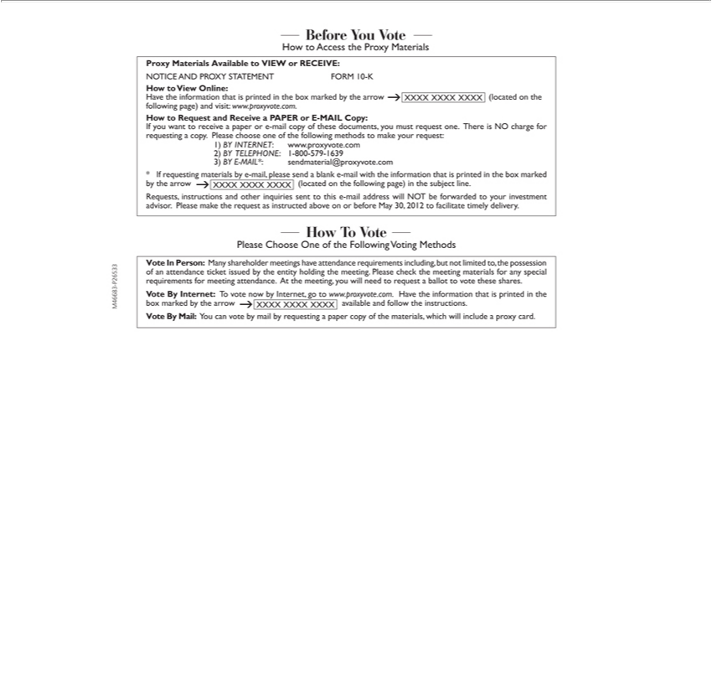

— Before You Vote —
How to Access the Proxy Materials
Proxy Materials Available to VIEW or RECEIVE:
NOTICE AND PROXY STATEMENT FORM 10-K
to View Online:
ave the information that is printed in the box marked by the arrow XXXX XXXX XXXX (located on the following page) and visit: www.proxyvote.com.
How to Request and Receive a PAPER or E-MAIL Copy:
If you want to receive a paper or |  | -mail copy of these documents, you must request one. There is NO charge for requesting a copy. Please choose one of the following methods to make your request:
1)INTERNET www.proxyvote.com
2) | 1-800-579-1639 |  | .com
3) BY TELEPHONE:-MAIL*: |  |  | .com
* If requesting materialssendmaterial@proxyvoteby-mail,pleasesend a blank e-mail with the information that is printed in the box marked by the arrow XXXX XXXX XXXX (located on the following page) in the subject line. Requests, instructions and other inquiries sent to this e-mail address will NOT be forwarded to your investment advisor. Please make the request as instructed above on or before May 30, 2012 to facilitate timely delivery.
Please One of the Following Voting Methods

Vote In Person: Many shareholder meetings have attendance requirements including, but not limited to, the possession of an attendance ticket issued by the entity holding the meeting. Please check the meeting materials for any special requirements for meeting attendance. At the meeting, you will need to request a ballot to vote these shares.
^{Vote By}
Mail:Internet:YouTocanvotevotenowbybymailInternet,byrequestinggotowww.proxyvote.com.apapercopyofthe materials,Havethe informationwhichwillincludethatisprintedaproxyincard.the box marked by the arrow XXXX XXXX XXXX available and follow the instructions.

M46683-P26533

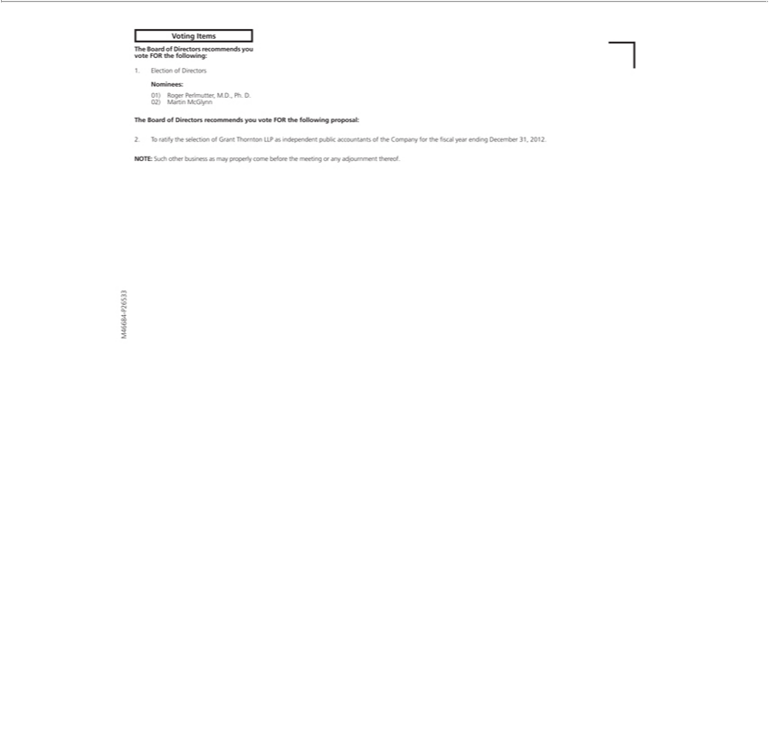

Voting Items
The Board of Directors recommends you vote FOR the following:
Nominees:1.Election of Directors
⁰²⁾
1) MartinRogerPerlmutter,McGlynn M.D., Ph. D.
The Board of Directors recommends you vote FOR the following proposal:
^{NOTE:}
2. o ratifySuchtheotherselectionbusinessofGrantasmayThorntonproperlyLLPcomeas beforeindependentthemeetingpublicoraccountantsanyadjournmentofthe Companythereof. for the fiscal year ending December 31, 2012.

M46684-P26533



M46685-P26533

