UNITED STATES

SECURITIES AND EXCHANGE COMMISSION
Washington, D.C. 20549

FORM 8-K

CURRENT REPORT

Pursuant to Section 13 or 15(d)

of the Securities Exchange Act of 1934

Date of Report (Date of earliest event reported): August 17, 2020

MICROBOT MEDICAL INC.

(Exact name of registrant as specified in its charter)

Delaware | 000-19871 | 94-3078125
(State or other jurisdiction | (Commission | (IRS Employer
of incorporation) | File Number) | Identification No.)
 | 25 Recreation Park Drive, Unit 108
 | Hingham, Massachusetts 02043
 | (Address of Principal Executive Offices) (Zip Code)
 | Registrant’s telephone number, including area code: (781) 875-3605
 | (Former Name or Former Address, if Changed Since Last Report)

Check the appropriate box below if the Form 8-K filing is intended to simultaneously satisfy the filing obligation of the registrant under any of the following provisions:

- ] Written communications pursuant to Rule 425 under the Securities Act (17 CFR 230.425)

- ] Soliciting material pursuant to Rule 14a-12 under the Exchange Act (17 CFR 240.14a-12)

- ] Pre-commencement communications pursuant to Rule 14d-2(b) under the Exchange Act (17 CFR 240.14d-2(b))

- ] Pre-commencement communications pursuant to Rule 13e-4(c) under the Exchange Act (17 CFR 240.13e-4(c)) Securities registered pursuant to Section 12(b) of the Act:

Title of each class |  | Trading Symbol(s) |  | Name of each exchange on which registered
Common Stock, $0.01 par value |  | MBOT |  | NASDAQ Capital Market

Indicate by check mark whether the registrant is an emerging growth company as defined in Rule 405 of the Securities Act of 1933 (17 CFR §230.405) or Rule 12b-2 of the Securities Exchange Act of 1934 (17 CFR §240.12b-2).

Emerging Growth Company [ ]

If an emerging growth company, indicate by check mark if the registrant has elected not to use the extended transition period for complying with any new or revised financial accounting standards provided pursuant to Section 13(a) of the Exchange Act. [ ]

Item 7.01 Regulation FD Disclosure.

On August 17, 2020, Microbot Medical Inc. (the “Company”) (a) issued a press release announcing and (b) posted presentation materials on its website with respect to, among other things, the results of a feasibility animal study performed using the Company’s LIBERTYTM Robotic System.

The Company is attending the Needham Virtual Med Tech and Diagnostics Conference on August 17, 2020, where it will share the initial results.

The presentation materials can be accessed via the ‘Investors’ section, under ‘Presentation + Resources,’ of the Company’s website at www.microbotmedical.com. The Company is not undertaking to update these presentation materials.

The press release and presentation materials furnished as Exhibit 99.1 and Exhibit 99.2, respectively, to this Current Report on Form 8-K are incorporated herein by reference. The information in this report (including Exhibits 99.1 and 99.2) is being furnished pursuant to Item 7.01 and shall not be deemed to be “filed” for the purposes of Section 18 of the Securities Exchange Act of 1934, as amended, or otherwise subject to the liabilities of that section. This report will not be deemed an admission as to the materiality of any information herein (including Exhibits 99.1 and 99.2).

Item 9.01. Financial Statements and Exhibits.

(d) Exhibits
Exhibit
Number |  | Description
99.1 |  | Press Release
99.2 |  | Presentation Materials

SIGNATURES

Pursuant to the requirements of the Securities Exchange Act of 1934, the Registrant has duly caused this report to be signed on its behalf by the undersigned thereunto duly authorized.

MICROBOT MEDICAL INC.

By: /s/ Harel Gadot

Name: Harel Gadot

Title: Chief Executive Officer, President and Chairman

Date: August 17, 2020

Exhibit 99.1
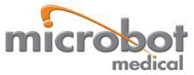

Microbot Medical Announces Successful Animal Study Utilizing Its LIBERTYTM Robotic System

World’s First Fully Disposable Surgical Robot Achieved all Endpoints with No Intraoperative Adverse Events

Remotely Performed Procedures have the Potential to Reduce Radiation Exposure, Physical Strain and Cross Contamination to Both the Patients and the Surgical Staff

HINGHAM, Mass., August 17, 2020 – Microbot Medical Inc. (Nasdaq: MBOT), today announced the successful conclusion of its feasibility animal study using the Company’s LIBERTYTM Robotic System, the world’s first fully disposable surgical robotic system. The study met all of its end points with no intraoperative adverse events, which supports the Company’s objectives to allow physicians to conduct a catheter-based procedure from outside the catheterization laboratory (cath-lab), avoiding radiation exposure, physical strain and the risk of cross contamination. It was performed by two leading physicians in the neuro vascular and peripheral vascular intervention spaces, and the results demonstrated robust navigation capabilities, intuitive usability and accurate deployment of embolic agents, most of which was conducted remotely from the cath-lab’s control room.
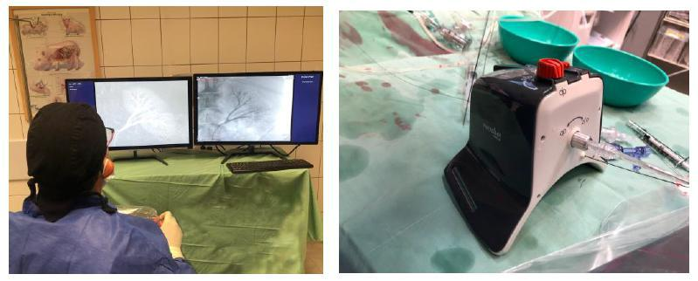

“We continue to validate the LIBERTYTM Robotic System and confirm our assertion that it has the potential to revolutionize the robotic surgery space by democratizing endoluminal procedures with enhanced clinical and economical outcomes,” commented Harel Gadot, CEO, President and Chairman. “The
freedom from capital equipment, coupled with the ability to operate LIBERTYTM remotely, especially in today’s COVID-19 healthcare environment, will potentially reduce the cross contamination between the surgical staff and patients on top of reducing radiation exposure. Overall, we believe that we are in the right market, at the right time and with the right solution.”

Mr. Gadot, along with other members of the management team, will be sharing these results at the Needham Virtual Med Tech & Diagnostics Conference being held today. A copy of the investor presentation, which highlights the initial results of the feasibility animal study, can be accessed via the ‘Investors’ section, under ‘Presentation + Resources’ of the Company’s website at www.microbotmedical.com.

The Company believes that the LIBERTYTM Robotic System, which was unveiled in January 2020, is the world’s first fully disposable robotic system which features a unique compact design; With the capability to be operated remotely, it is being designed to reduce radiation exposure, the physical strain to the physician as well as cross contamination between the surgical staff and patients. In addition, incorporating the technology the Company acquired

from CardioSert into the LIBERTYTM Robotic System, has the potential to eliminate the use of multiple consumables through its “One & Done” capabilities.

About Microbot Medical

Microbot Medical Inc. (NASDAQ: MBOT) is a pre-clinical medical device company that specializes in transformational micro-robotic technologies, focused primarily on both natural and artificial lumens within the human body. Microbot’s current proprietary technological platforms provide the foundation for the development of a Multi Generation Pipeline Portfolio (MGPP).

Microbot Medical was founded in 2010 by Harel Gadot, Prof. Moshe Shoham, and Yossi Bornstein with the goals of improving clinical outcomes for patients and increasing accessibility through the use of micro-robotic technologies. Further information about Microbot Medical is available at http://www.microbotmedical.com.

Safe Harbor

Statements pertaining to the registered direct offering, timing, the amount and anticipated use of proceeds and statements pertaining to future financial and/or operating results, future growth in research, technology, clinical development, and potential opportunities for Microbot Medical Inc. and its subsidiaries, along with other statements about the future expectations, beliefs, goals, plans, or prospects expressed by management, constitute forward-looking statements within the meaning of the Private Securities Litigation Reform Act of 1995 and the Federal securities laws. Any statements that are not historical fact (including, but not limited to statements that contain words such as “will,” “believes,” “plans,” “anticipates,” “expects” and “estimates”) should also be considered to be forward-looking statements. Forward-looking statements involve risks and uncertainties, including, without limitation, market conditions and the satisfaction of customary closing conditions, risks inherent in the development and/or commercialization of potential products,

including LIBERTYTM, the outcome of its studies to evaluate the SCS and other existing and future technologies, uncertainty in the results of pre-clinical and clinical trials or regulatory pathways and regulatory approvals, uncertainty resulting from the COVID-19 pandemic, need and ability to obtain future capital, and maintenance of intellectual property rights. Additional information on risks facing Microbot Medical can be found under the heading “Risk Factors” in Microbot Medical’s periodic reports filed with the Securities and Exchange Commission (SEC) and in the prospectus supplement related to the registered direct offering to be filed with the SEC, which are or will be available on the SEC’s web site at www.sec.gov. Microbot Medical disclaims any intent or obligation to update these forward-looking statements, except as required by law.

Investor Contact:

Michael Polyviou

EVC Group

mpolyviou@evcgroup.com

732-933-2754

Exhibit 99.2


